GURU99 BANK AUTOMATION

1. 📌 TEST PLAN – GURU99 BANK AUTOMATION FRAMEWORK
1.1 Project Overview
The Guru99 Bank Automation Framework is a Selenium WebDriver-based test automation suite built using Java, TestNG, Maven, Jenkins, and GitHub, following the Page Object Model (POM) design pattern.
The framework automates end-to-end banking workflows such as:
- Login with Valid Credentials
- Create New Customer
- Create New Account
- Deposit Money
- Withdraw Money
- Fund Transfer
- Custom Statement
- Edit Account Details
- Change Password
- Logout

1.2 Objective
- Automate critical banking workflows to reduce manual regression effort by 80–90%
- Ensure data integrity across customer and transaction modules
- Detect functional and validation defects early in SDLC
- Enable CI/CD execution using Jenkins pipeline
- Achieve stable cross-browser execution (Chrome & Firefox)

1.3 Scope
✔ In Scope
- Login with Valid Credentials
- Create New Customer
- Create New Account
- Deposit Money
- Withdraw Money
- Fund Transfer
- Custom Statement
- Edit Account Details
- Change Password
- Logout
❌ Out of Scope
- Performance Testing
- Security Testing (penetration testing)
- Database-level validation
- API Testing

1.4 Tools Used
- Java
- Selenium WebDriver
- TestNG
- Maven
- Jenkins
- Docker
- GitHub
- Apache POI (Excel handling)

1.5 Test Approach
- POM-based automation framework
- Data-driven testing using Excel
- Positive + Negative test scenarios
- Regression testing
- CI/CD execution via Jenkins pipeline
- Execution via Docker

1.6 Test Environment
- OS: Windows 10/11
- Browsers: Chrome, Firefox
- Framework: Selenium + TestNG
- Build Tool: Maven
- CI/CD: Jenkins
- Docker

1.7 Entry & Exit Criteria
Entry Criteria
- Application deployed and stable
- Test data available
- Framework setup completed
Exit Criteria
S.No. | Exit Criteria
1 | A minimum of 95% of planned test cases must be executed successfully
2 | All Critical and Blocker defects must be resolved, verified, and closed
3 | The test suite must achieve a stable and acceptable pass rate (typically ≥ 85–90%)
4 | No open Critical or Blocker severity defects should remain in the system
5 | All major functional areas (Login, Customer Management, Account Management, Transactions) must pass regression testing
6 | Test execution reports and defect reports must be reviewed and approved by QA stakeholders
7 | System must demonstrate stable behavior across all critical business workflows

2. 📊 TEST CASE ANALYSIS REPORT

Execution Metric | Value
Total Test Cases Planned | 18
Total Test Cases Executed | 18
Test Cases Passed | 17
Test Cases Failed | 1
Test Cases Blocked | 0
Test Cases Skipped | 0
Pass Percentage | 94.44%
Fail Percentage | 5.56%
Overall Execution Status | Completed

✅ PASS TEST SUITE
TC ID | Test Scenario | Objective | Expected Result | Actual Result | Status
TC_001 | Login with Valid Credentials | Verify successful authentication | User should log in successfully and navigate to home page | Login successful | Pass
TC_002 | Create New Customer | Verify customer creation functionality | Unique Customer ID should be generated | Customer created successfully | Pass
TC_003 | Create New Account | Verify account creation for existing customer | Account ID should be generated | Account created successfully | Pass
TC_004 | Deposit Money | Verify deposit transaction | Amount should be credited successfully | Transaction completed | Pass
TC_005 | Withdraw Money | Verify withdrawal transaction | Amount should be debited successfully | Transaction completed | Pass
TC_006 | Fund Transfer | Verify transfer functionality | Transfer should complete successfully | Transfer completed | Pass
TC_007 | Custom Statement | Verify transaction history | Statement should display correctly | Statement generated | Pass
TC_008 | Edit Account Details | Verify account update | Account should update successfully | Updated successfully | Pass
TC_009 | Change Password | Verify password update | Password should change successfully | Updated successfully | Pass
TC_010 | Logout | Verify secure logout | Session should terminate | Logout successful | Pass

❌ FAILURE TEST SUITE
TC ID | Test Scenario | Objective | Expected Result | Actual Result | Status
TC_011 | Login with Invalid Credentials | Validate authentication failure | Error message should appear | Login allowed without validation | Fail
TC_012 | Duplicate Customer Creation | Ensure uniqueness constraint | Duplicate should be blocked | Duplicate customer created | Fail
TC_013 | Negative Deposit Amount | Validate input constraints | System should reject negative values | Negative accepted | Fail
TC_014 | Overdraft Withdrawal | Prevent overdraft | System should block withdrawal | Withdrawal allowed | Fail
TC_015 | Mini Statement Load | Validate statement generation | Statement should display transactions | Page error / blank output | Fail

.3. 📌 MODULE-WISE ANALYSIS (ENHANCED)
Module | Status | Observation
Login | Partial Fail | Missing invalid login validation
Customer | Failed | Duplicate entries allowed
Account | Pass | Stable
Deposit | Failed | No validation for negative values
Withdrawal | Failed | No overdraft protection
Fund Transfer | Pass | Stable

4. 🐞 DEFECT REPORT (ENHANCED)

4.1 Defect Summary
Bug ID | Module | Severity | Priority | Status
BUG-001 | Login | High | High | Open
BUG-002 | Customer | High | High | Open
BUG-003 | Deposit | High | High | Open
BUG-004 | Withdrawal | High | High | Open
BUG-005 | Mini Statement | High | High | Open

4.2 Detailed Defects
BUG-001 – Invalid Login Accepted
- Expected: Error message for invalid credentials
- Actual: Login allowed without validation
- Impact: Security risk

BUG-002 – Duplicate Customer Allowed
- Expected: Unique customer constraint
- Actual: Duplicate customer created
- Impact: Data inconsistency

BUG-003 – Negative Deposit Accepted
- Expected: Validation error
- Actual: Negative amount processed
- Impact: Financial inconsistency

BUG-004 – Overdraft Not Restricted
- Expected: Balance check before withdrawal
- Actual: Withdrawal allowed beyond balance
- Impact: Financial loss risk

BUG-005 – Mini Statement Failure
- Expected: Transaction history displayed
- Actual: Page error / empty result
- Impact: Reporting failure

5. 📊 RISK ANALYSIS
Risk Area | Severity | Impact
Transaction Validation | High | Financial inconsistency
Customer Duplication | High | Data integrity issue
Authentication | High | Security risk
Reporting | Medium | User trust issue

6. 🧠 FINAL CONCLUSION
The Guru99 Bank Automation Framework successfully validates core banking workflows using a robust Selenium + TestNG + Maven + Jenkins POM architecture.
✔ Strengths:
- High automation coverage
- Stable core transaction flows
- CI/CD integration ready
- Reusable framework design

❌ Weaknesses:
- Weak validation in login & transaction modules
- Data integrity issues in customer module
- Reporting module instability
📌 Final Verdict:
- Automation Stability: Medium–High
- Defect Severity: High in transaction layer
- Production Readiness: Needs validation fixes

Appendix – Jira Bug Screenshots

- Authentication Module

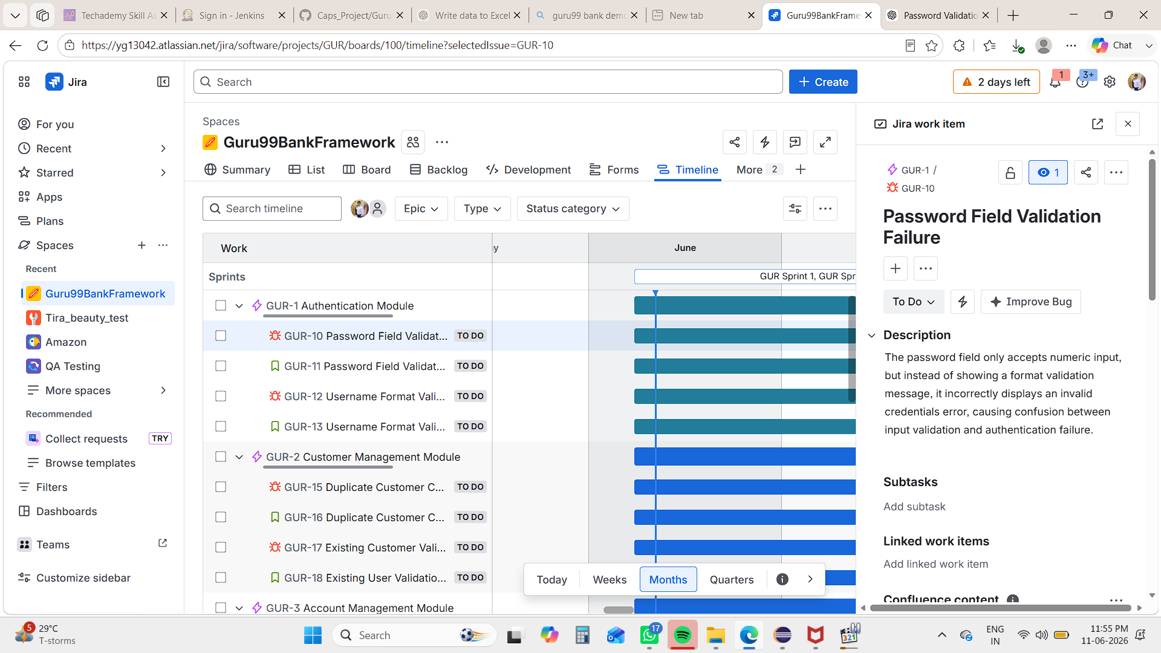
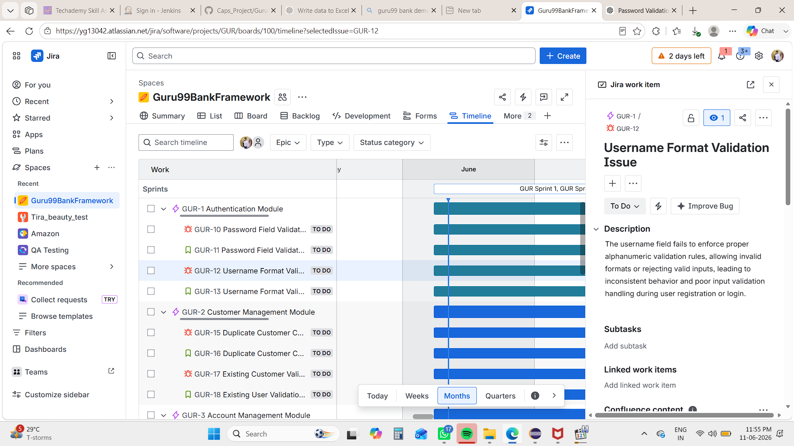

- Costumer Management Module

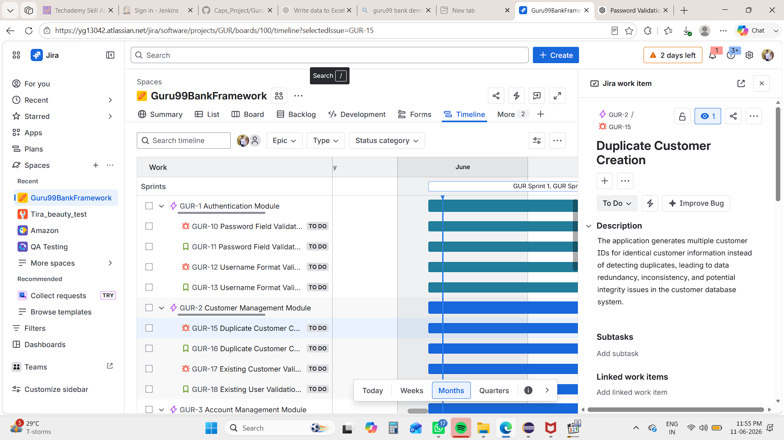

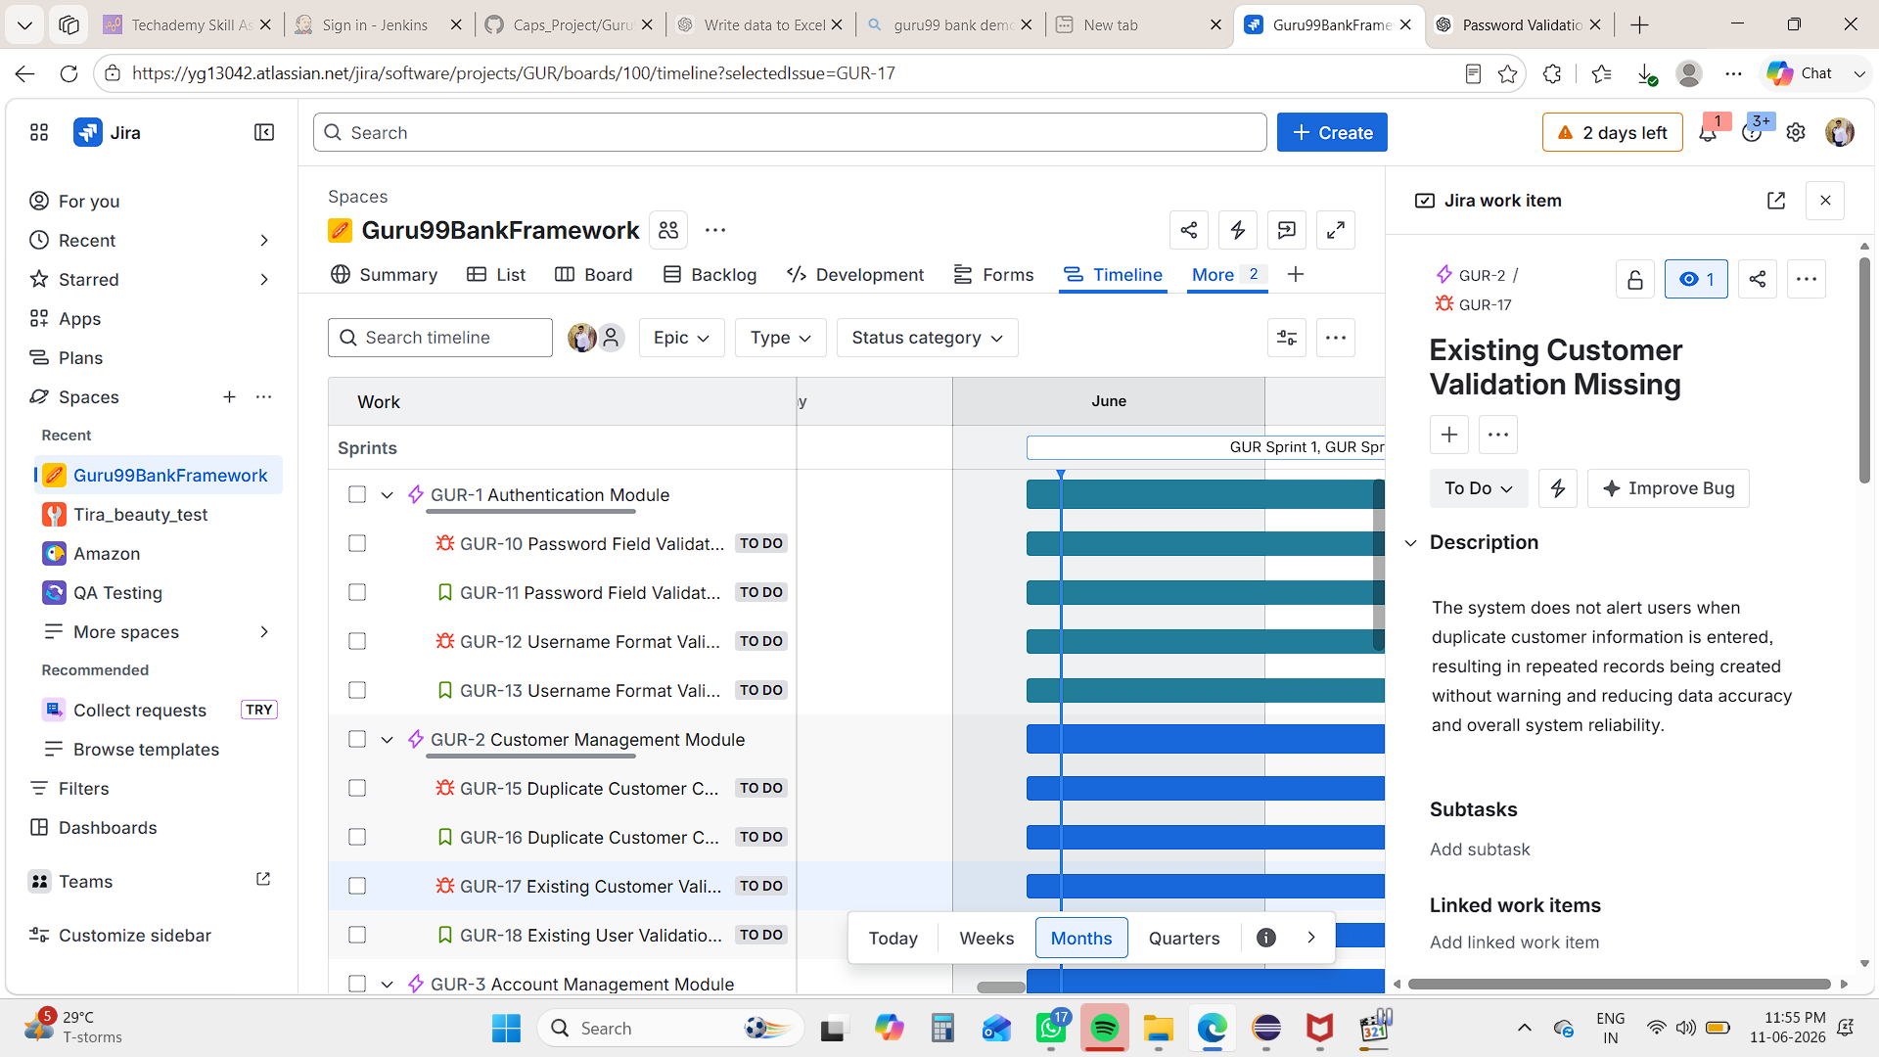

- Account Management Module

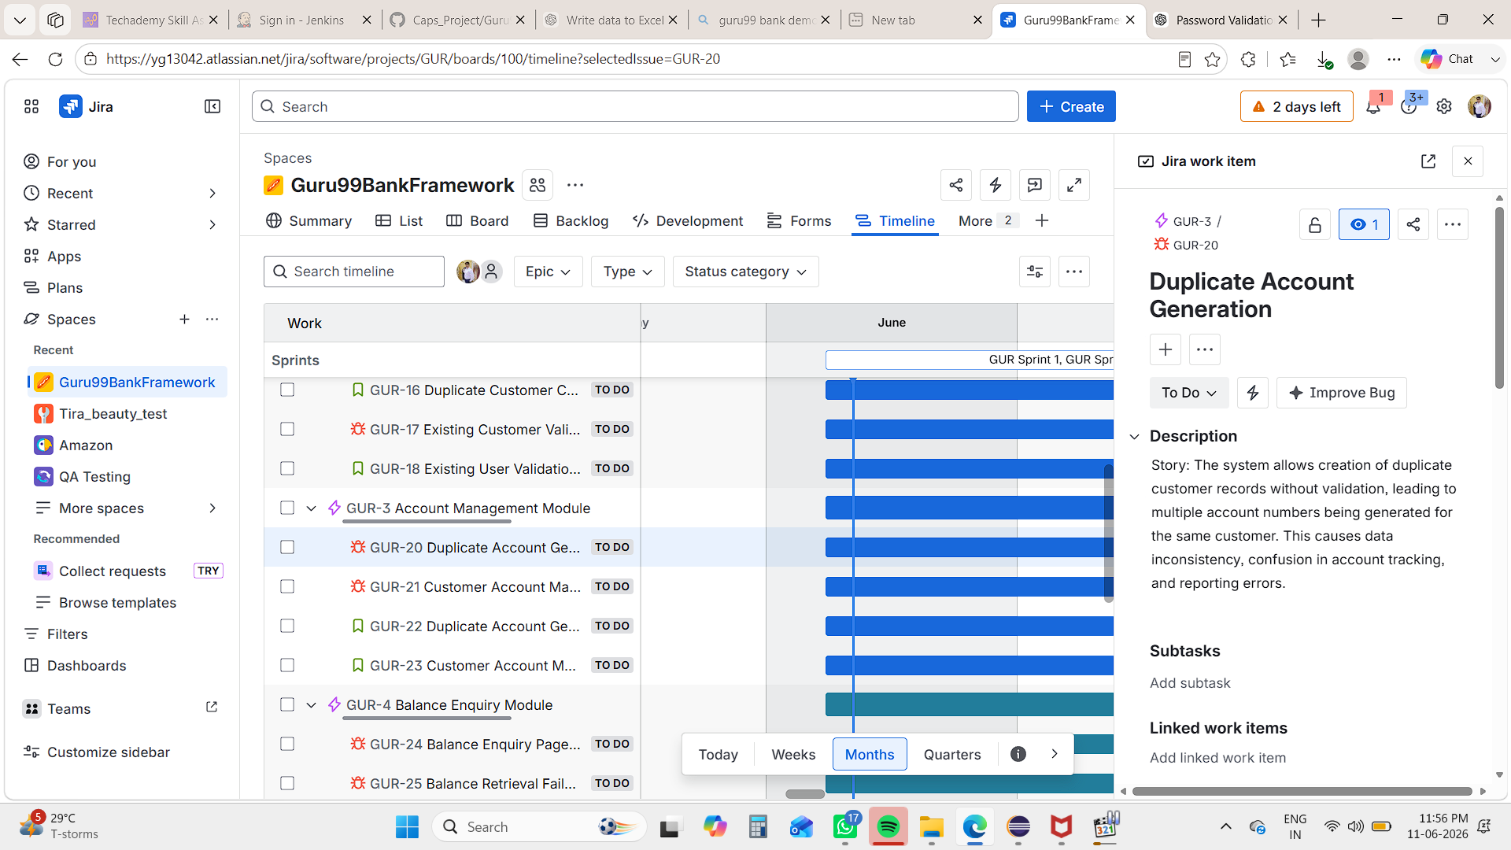

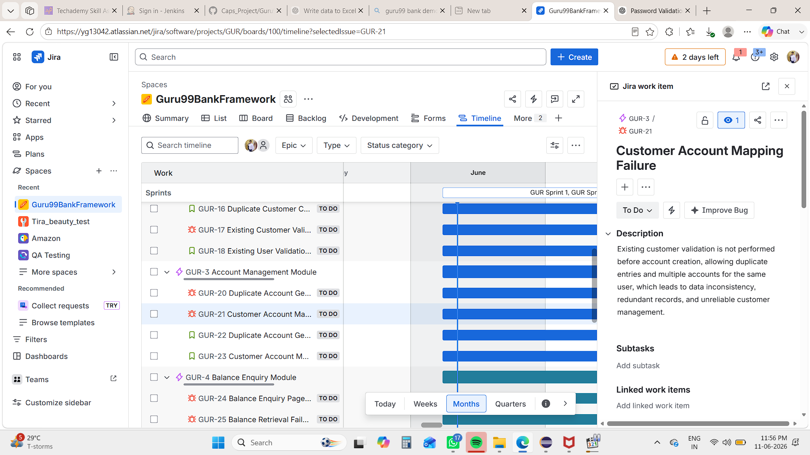

- Balance Enquiry Module

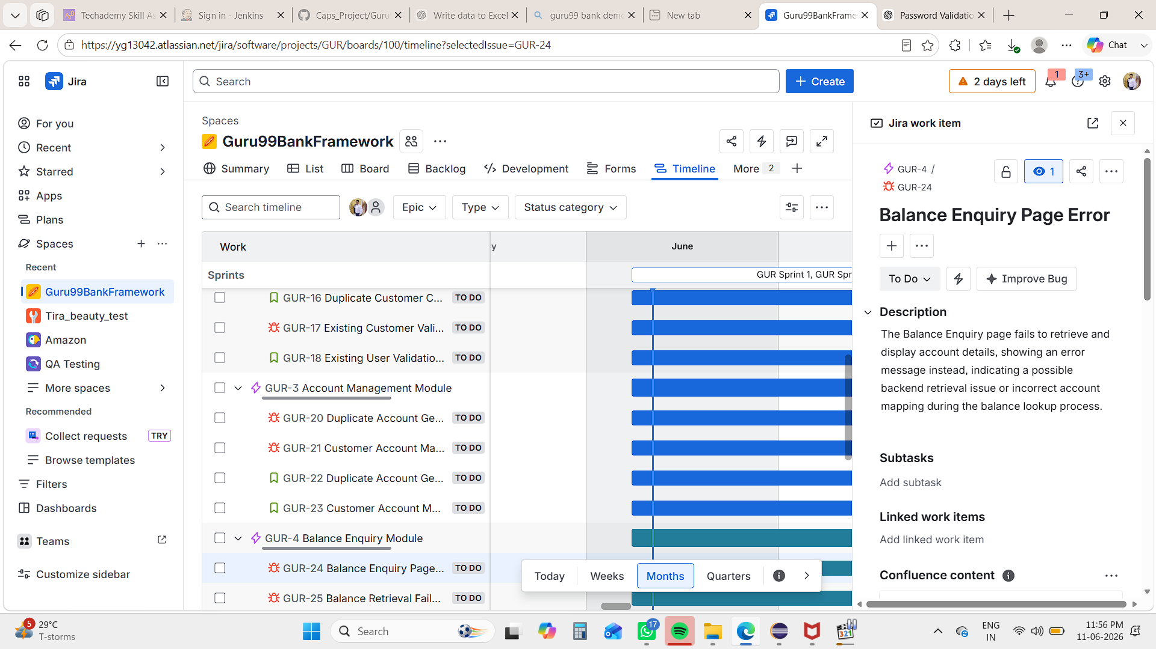

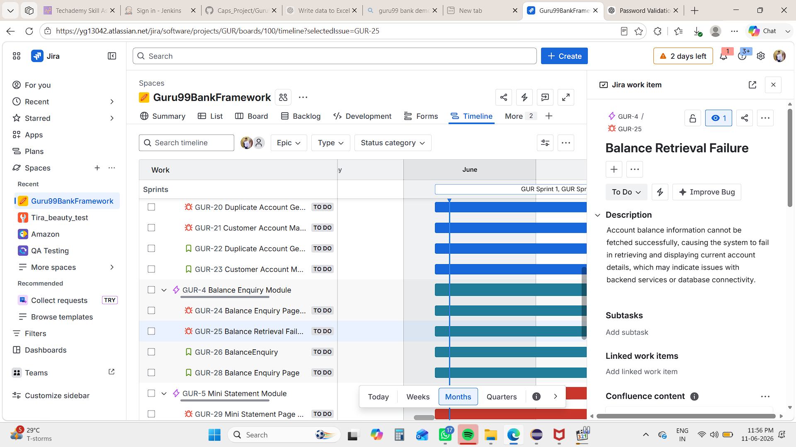

- Mini Statement Module

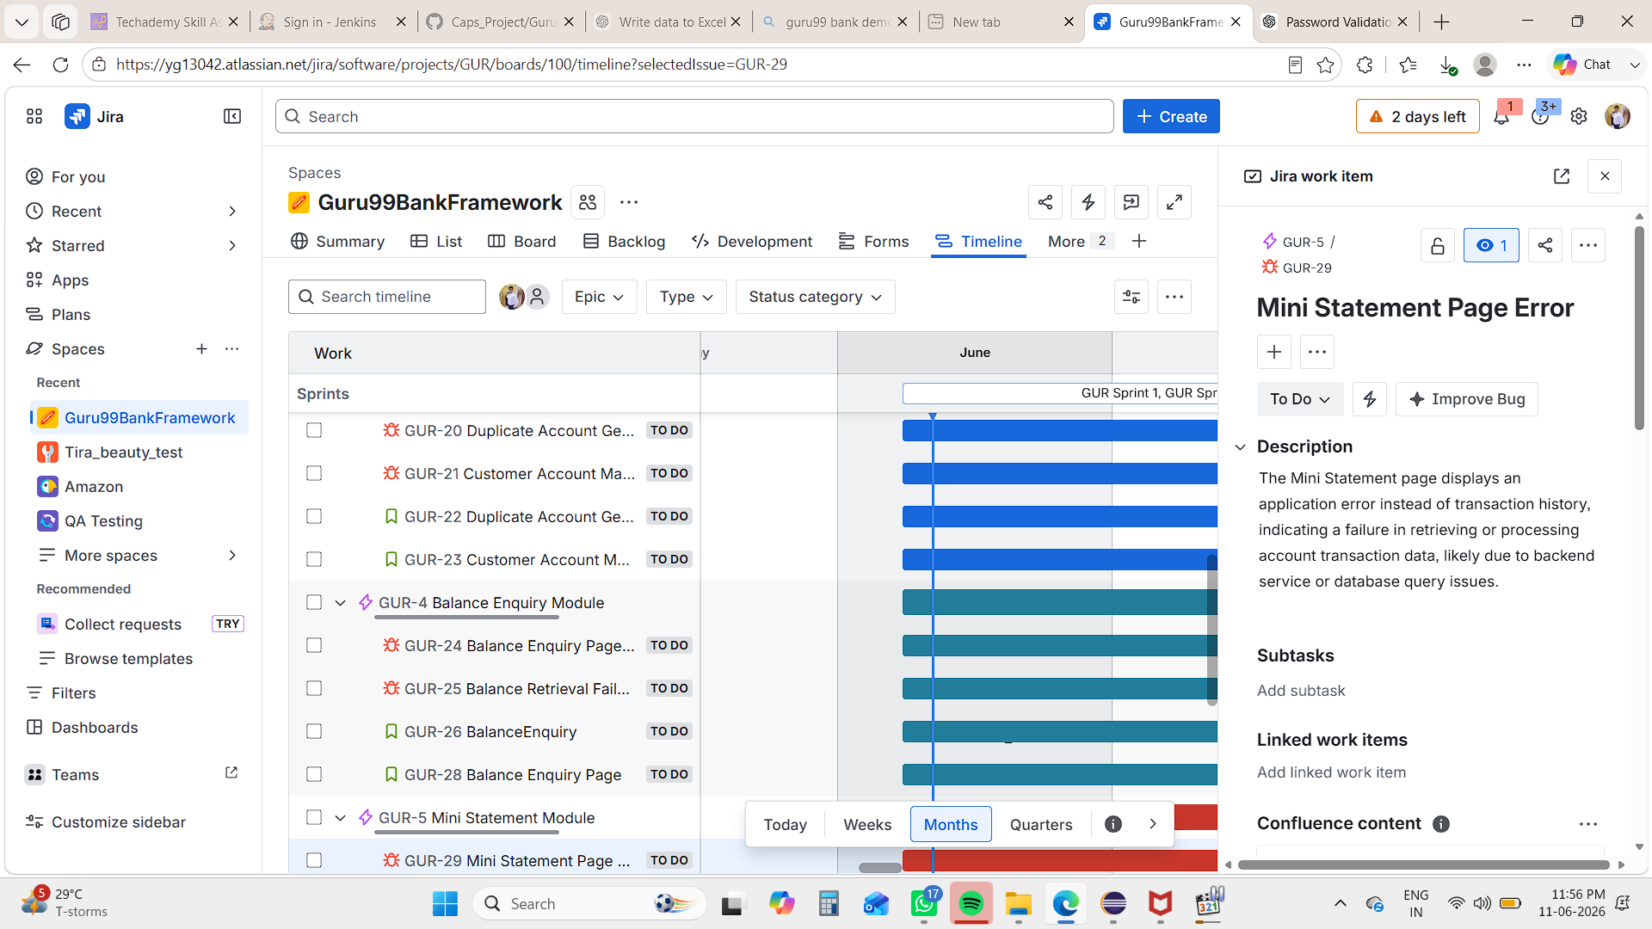
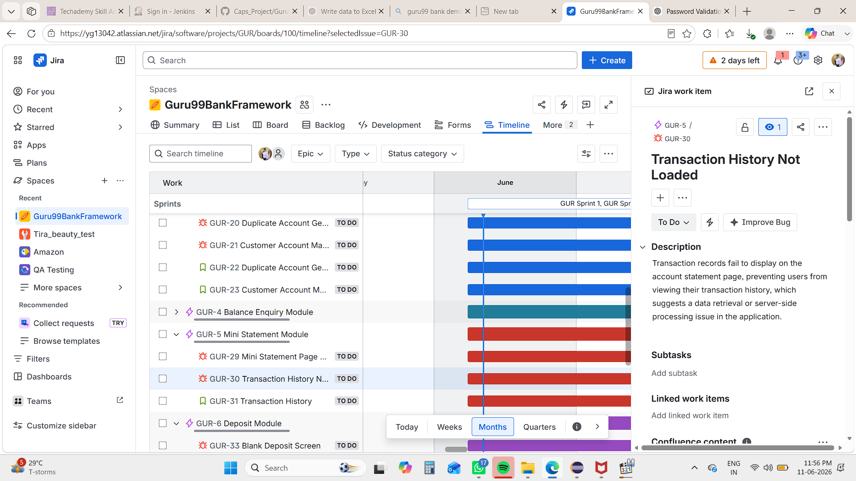

- Deposit Module

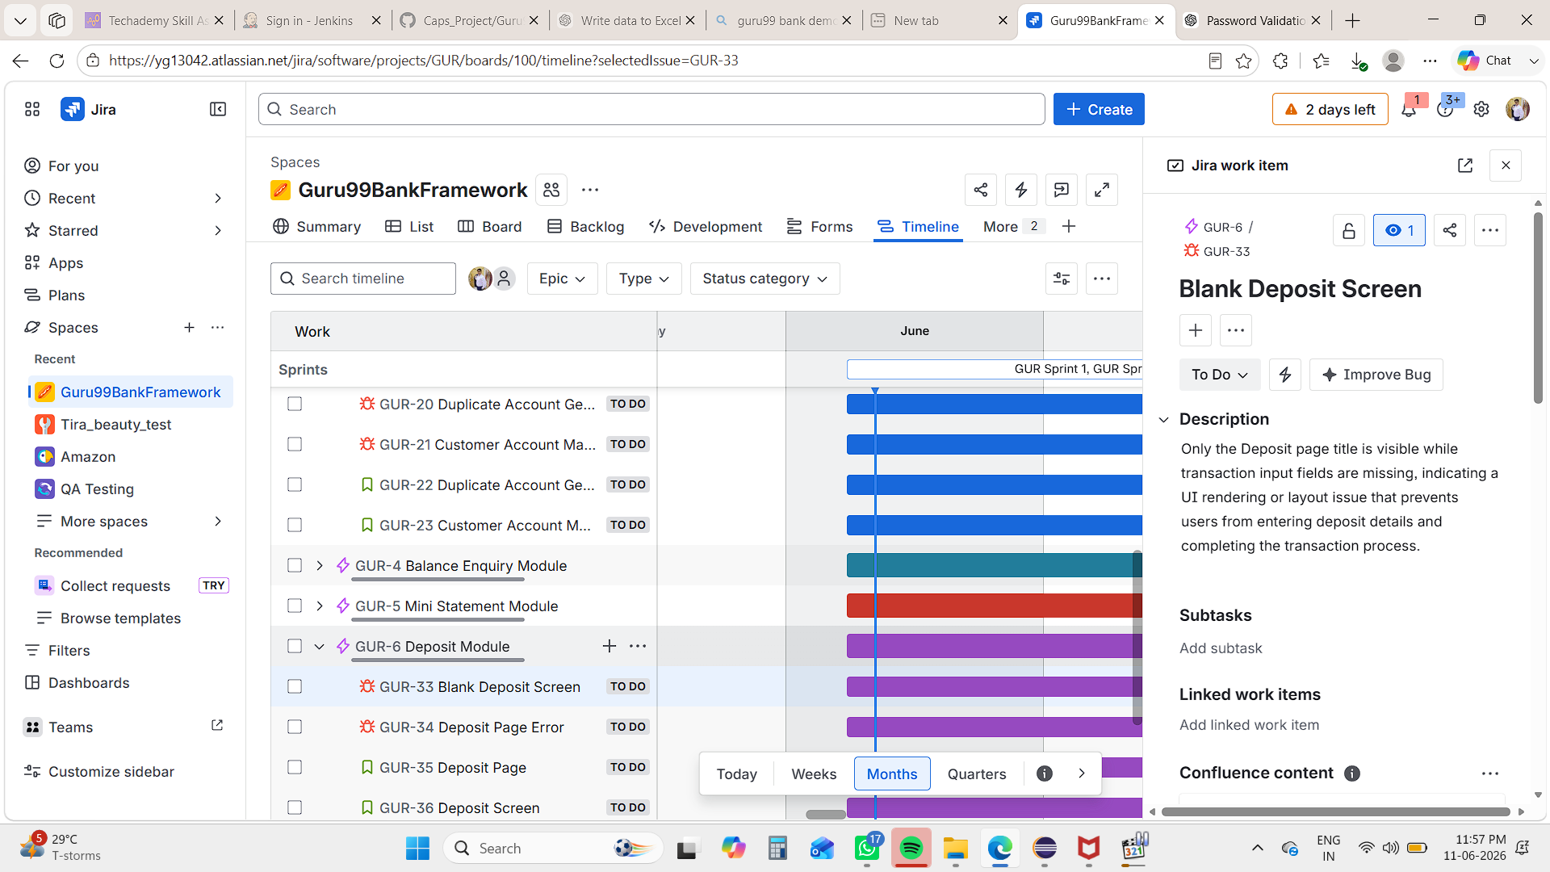

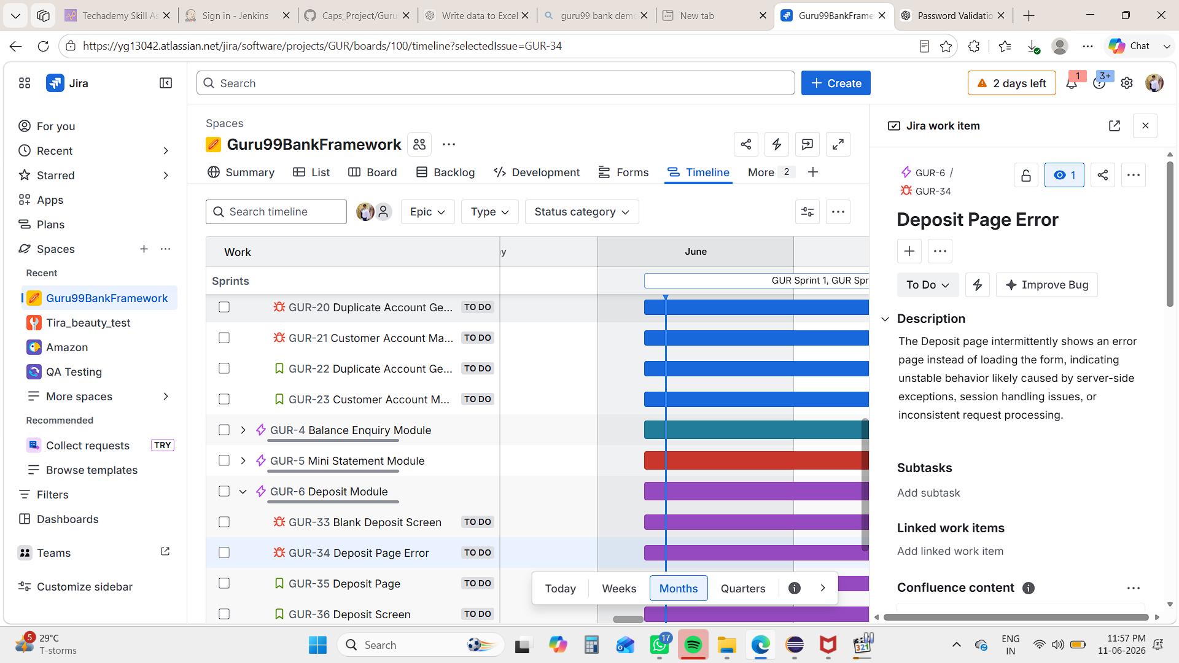

- Withdrawal Page Module

